Shadoxhurst Community Forum – Minutes
44th Village Forum Meeting
on
Monday 6th March 2023
In the Village Hall at 7.30pm
- To maintain the quality of life for all in the village
- To generate issues that could be put to the Parish Council
- To re-kindle community spirit and engender friendship
- To build a social feeling in the village
- To suggest things that will bring people together
- With a Vision to create and develop a positive community spirit.

Purpose of the meeting was primarily to discuss Kings Coronation event.

- Welcome and apologies; welcomed John Ward from the scout group
- Positions of Chairman/Facilitator and Notetaker - Peter/Lis respectively

- Kings Coronation – Joint event with the Kings Head Pub (see appendix)
- Matters arising from January/February meeting minutes not on agenda. PRS/PPL licence Still being investigated by Emma although it seems as the SPC, as owner of the properties, is classed as a “Local Authority” the fee for a generic licence is significant so it was proposed (at the SPC meeting on Wednesday 8th) that individual licences will need to be requested as in the past.
- Review of Murder night – Total £357.75 raised, £125 donated to Murder again’ s current charity - Ashford and Romney Marsh Breathe Easy Support Group. No further discussion needed at this stage.

It was mentioned at this point that the sound system had needed some repairs and that £50 had been spent from forum funds to do this. In future it was suggested that the flower arrangers, (not a forum club) should pay £5 per hire use.

Peter will hand over £272.02 raised at recent events (less expenses) to the parish council at their meeting on Wednesday.

- Games and Social evenings (17th Feb, 17th Mar & 21st Apr). The first event was fairly well attended – History club display opened; some additional interest muted. Other clubs still to put on display. Location of activities for event 17th March discussed to include Peter and Lis’ air hockey table (see availability sheet for set up/running). Peter will bring in milk for teas/coffees. Action to ask other village clubs to put up displays in boards to gain interest in them.

- Barn dance - 15/4/23 Approx 25 tickets sold, would like nearer 40 min. Marketing to be increased to areas “4” and “5” (as determined by Hannah) on Facebook. Advertise on Next Door to Shadoxhurst and immediate local areas. It will be “pinged” on the What’s on page.

Numbers/food etc. will be finalised at April meeting; Alison to provide Peter with list of items that need to be purchased to ascertain whether a Bookers run is viable/required. No additional kitchen equipment was deemed necessary.
- Future events member availability form - updated version attached – still awaiting reply from Cheryl.

- Club News – nothing to report.

- Parish Council Update – a short discussion took place regarding the planning application for the pavilion site.

- Any Other Business.

    - Community Facebook page – Hannah – working well, updates as under other events.
    - Hall hire fees - Parish council meeting due this week where the proposal for clubs (except coffee) to pay £5 for meetings/events from April will be discussed. Post meeting update this £5 per hour was agreed; this does not include our forum monthly meeting. Forum to advise our clubs accordingly.
    - Scouts John explained the situation with the whole scout group, needing to recruit etc. they are short of parent helpers. They have 3 leaders, Kim – Beavers, Morag – Cubs, Matthew - Scouts as well as himself overseeing all (as well as other areas). John advised the group they may be able to help with planters for the village, litter picking (see below), boot fairs ( washing cars/parking?) as activities towards various badges.
They may be looking towards an open day for recruitment. It was suggested that village club members might visit scout meetings to advertise other clubs in village (mainly to parents). The scouts are to be advised of the games and social evenings. (see also coronation event).
    - Newsletter- David asked for reports etc for 15th March. This to include an advert for the Kings coronation event for the front page (so please keep club news brief). We also discussed the format of the newsletter – decided to look at again when more time (Hannah to liaise with David).
    - Cooking utensils – a brief discussion took place regarding the equipment ideas circulated by email. It was decided to review this after the barn dance event.

- Date of next meeting – 3rd April 2023.

- Dates of future meetings: - Due to Bank Holidays and Coronation Event our May meeting will be held from 4.30pm (before games and social evening) on Friday 21st April – primarily to discuss Kings coronation event.

APPENDIX
Kings Coronation Event
Forum Element to be Open to Public from 12 – 6pm and continued into the evening as decided upon by the pub

Time Line – suggested

- Set-up by 12.00 mid-day
- 12 – 6 - Ice Cream Van – supplier identified and booked (Crown Ices as per the Queens Jubilee Event).

- 12-5 Scout group – Stocks and craft table

- 12.30-1pm Millie Grace Bacon Dance Academy
- 1 – 5 - Face Painter – supplier identified, awaiting ordering (£40/hour – free to user). Booked – Fancy That - same as at the Queens Jubilee
- 12 – 5 - Bouncy Castle – Booked – Bouncers Bouncy Castles (Woodchurch) small for <10 year olds with supervision (£65 <10 & £25/hour supervision, free to user). 13A power supply from the pub to run – all cabling supplied with hire.
- 1 – 2 & 3-4? - Live Band –Katrina had 2 possibilities; Steelworks and Move over Dali Post meeting – suggested we go with Move over Dali ( group known to forum members) at £300
- 2 -3 - Morris Dancers – identified, timing/cost to be confirmed – The Woodchurch Morris group have confirmed coming but not given time/fees as yet Claire (KH) to confirm time group available, cost, etc. at meeting we would prefer them to do 2-3.
- 1 – 3? Food Offering – Michelle (pub chef) will provide a limited menu in the pub, along with pulled pork, hot dogs, etc. veg/vegan option/Jack Fruit? Suggested price £2.50 per offering. Jugs of Pimms were suggested if good day. Alison and possibly others with Level 2 to help out with this.

- 12 – 5? Squash / water to be available free of charge

- 4 - 4.30 Vanessa dance display Action Cheryl confirm time ok with Vanessa and her costs please.
- 5 - 6 clear down and finish

In addition, it was agreed that the forum would supply gazebos to use on the day. Also a few games tables (with Jenga, connect four, etc) would be available for children along with the rest of the crowns for decoration – felt tips to be purchased. Action Lis/Peter. Scouts can also provide mess tent /gazebo if needed.

The forum has plenty of bunting that can be used. Hannah to sort Banners

A draft site plan of the Kings Head garden is included below to inform discussions as the next meeting 3rd April.

Future Events – Forum/Supporters availability

Item / Lead | Definite Yes | Definite No
Games and Social – Peter/Hannah/David  17th Feb  17th March  21st April | Lis, Peter - all  David (Feb/Mar)  Hannah - All | Apr – David not sure may be late
Barn Dance – Sam  15th April | David, Sam, Paul, Alison Hannah | Lis, Peter
Coronation Event – Peter  8th May | Peter, Lis, David, Sam, Alison, Paul | Hannah
Boot Fair – John  4th June  6th August | June – John, David, Sam, Paul, Karen, Ron Hannah  August – John, Sam, Paul, Hannah | August: David
Christmas Craft Fair – Hannah  25th November | Sam, Paul, Lis, Peter, Karen, Hannah
Christmas Quiz – Allison  1st December | Sam, Paul Karen. Ron (quiz masters) Hannah | Lis, Peter
Wreath Making – Hannah  2nd December | Sam Paul Hannah  (Lis and Peter before 12 only)

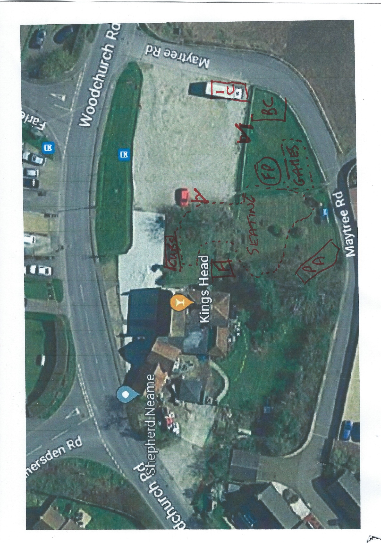
PA – Performance Area, FP – Face Painter, BC – Bouncy Castle, IC – Ice Cream van, F – Food / drinks, Cubs - Scouts

