Shadoxhurst Village Forum - Minutes
33rd Village Forum Meeting
on
Monday 4th April 2022
In the Village Hall at 7.30pm
- To maintain the quality of life for all in the village
- To generate issues that could be put to the Parish Council
- To re-kindle community spirit and engender friendship
- To build a social feeling in the village
- To suggest things that will bring people together
- With a Vision to create and develop a positive community spirit.

- Welcome and apologies for absences – no new volunteers
- Positions of Chairman/Facilitator and Note Taker remain with Peter
- No issues raised on the notes from previous meeting (7th March 2022).
- First half of 2022 Events:-
May – Music Quiz on either the 7th - Cheryl has contact/booking details published in the April newsletter.
- Queen’s Jubilee weekend in June. Details agreed:
- Review of “to do list” – items identified and who to progress
- A question had been raised with Hannah over provision of facilities for disabled attendees. The event will take place on an open, flat field with a disabled toilet – seating and tables were considered but, whilst the pavilion has some, reserving these, moving and setting them up was considered to be beyond the current volunteer resources. Obviously if someone requested help on the day then we’d do our best to help.
- Progress with:-
- Roving Entertainer – investigations have not identified any realistic options so this has been “parked”.
- Salsa dancing performance/taster session – draft running order prepared (see below), look to confirm with Cheryl/Vanessa
- Competitions/Community Involvement – no advance items planned so advertising to be made nearer the event.
- Promotion banner(s) – Hannah to produce design for circulation amongst members for comments and once agreed will arrange for production.
- Summary income/expenses – currently we have committed/spent £900 with a further £800 subject to confirmation. The provision of a memory/keep-sake item for the day was discussed – it was agreed that this should be progressed – see below also for proposed options.
- Field & village decorations – we have 100m of flag bunting and individually a few flags – Peter to look at and purchase more Jubilee specific items.
- A draft running order has been produced and is included within these minutes.
- A discussion took place over “token” items to be given away at the event to commemorate the event – these will include general give-aways and specific items linked to activities. It was agreed that these should be progressed – see items, numbers and costs included at the end of these notes.
- Ideas for events in the second half of the year:-
- July/August? - Car Boot Fair – John to pick a day and progress
- September – Race Night (John) – Activity confirmed date to be finalised.
- 8th October – Quiz (Karen confirmed in hand)
- 26th November – Saturday Craft Fair (Hannah)
- 3rd December – Christmas Wreath making workshop 2-4pm (Hannah) Request made for open pine cones as now is the time these will be available on the ground.
- Clubs and Groups news – All appear to be running without issues, details are included within the bi-monthly newsletter.
- Parish Council Updates –2 vacancies exist if anyone would like to join.
- Any Other Business – Emma provided a presentation from the Parish Council on plans to re-invigorate the Recreation field equipment and building. Favourably received and suggested that the PC undertake an “open event” to present to the public ahead of a planning application appearing on the ABC portal. Emma to discuss with the PC at the next meeting – due Wednesday the 13th April.
- Date of next meeting – Monday 9th May 2022, 19.30 in the Village Hall.

Proposed/Draft Running Order for Saturday 4th June 2022

12 Noon – start of event
12.30-1.15 – Opus 32
1.15 – Cake competition
1.30-2.00 – Currently vacant
(as Line dancers aren’t happy to use the concrete basketball court)
2.15-3.00 – Opus 32
3.00-3.45 – Welly throwing– speed test competitions.
3.45-4.30 – That 70’s Band
4.30-5.00 – Salsa dance demonstration
5.00-5.45 – That’s 70’s band
5.45 – Prize giving
6.00 – End of event

Memory / Keep Sake items

Badges (500) - for those attending Medals (50) – for those who helped

Medals (20) for Competition Winners Medals (100) for Craft Competition Entrants
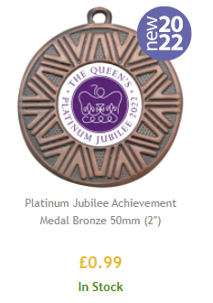
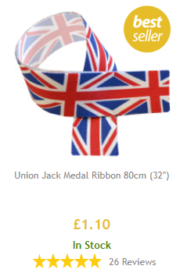
Ribbons (70) for Helper and Winner medals Pouches (100) to hold Entrant Medals

