NHW – Village Newsletter Update May 2021

The last two months has seen a sizeable number of alerts detailing various scams being attempted across the region – detials are published regularly on the village Facebook and Nextdoor web pages.

The below are a summary of those covered:-
- Delivery Scams – beware goods being delivered when not ordered.
- Discount Card and holiday – offers not expected/applied for.
- HMRC – requesting data to be provided via a supplied link.
- DVLA Phishing Emails - DVLA will never ask for bank details over an email
- Texts impersonating your Bank - If you receive a suspicious text like this and are not sure then contact your bank using a trusted number, which can normally be found on the back of your bank card.
- Pension Scams – A call out of the blue with a too good to be true offer.
- Impersonation of KCC Chartered Trading Standards Institute – a payment to cover legal costs is required to receive a refund of fraud against you.
- Post Office Phishing e.mail – claiming there is a problem making a delivery and clicking a link is required – do not press the link.
- British Gas – a link needs to be followed to claim a refund.
- New Census Scam – You receive a text message pretending to be from UK Government Census stating that information is missing from your application and direction to a website to update your details to avoid a £1,000 penalty.
Unfortunately vehicles speeding through the village remain a regular occurrence – please support the speed limit by driving responsibly. The limit is there to improve the quality of life for residents and to reduce the likelihood of death or serious injury to friends and neighbours taking exercise as well as the vehicle occupants.

There have been numerous reports in the media and posts concerning people being approached when out walking their dogs or dogs being taken from gardens. Please be vigilant to what is happening around you (avoid listening to music or using you mobile phone when walking). Vary your route and times plus consider walking with friends or neighbours. Incidents remain rare but please report suspicious vehicles or activities – take a picture if safe to do so – to the Police to allow them to possibly link what otherwise appear single/random items.

You can report items to the Police via 101 or using the Website (Chat apparently is quicker and easier than using the phone). If you would prefer to remain anonymous then use CrimeStoppers on 0800 555 111 or via their website https://crimestoppers-uk.org/give-information/forms/give-information-anonymously . Please include details of any vehicles – make, model and colour, as well as registration plate details.

Call 999 if you feel threatened or in danger – see contact details below for ways to contact the Police in non-urgent situations.

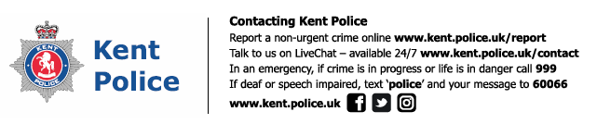

I continue to post items which I consider of interest, or useful information, from a Neighbourhood Watch perspective on both the village Facebook sites as well as the Nextdoor website. The Parish Council village website also has a Neighbourhood watch section with historic copies of these updates and other items of interest.
Neighbourhood Watch Co-ordinator Peter707R@Hotmail.com / 01233 732901

