**Monthly Updates from PCSO's**

My monthly PCSO update so you are aware of what myself and PCSO Carin Andrews have been up to in your villages, towns over the last month.

It has been another busy month with a variety of different calls and jobs. Our days are never the same. We deal with Scene preservation, road traffic collisions, reassurance visits and regular foot and mobile patrol.

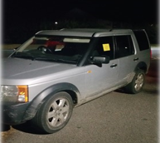

A member of the public reported that a vehicle was in a layby and had been there for a few days, and they thought it was not right. I attended and checked the vehicle and found out that it was stolen so I had it recovered and now it will be going back to the rightful owner.

I have also had the opportunity of being part of a planned operation to tackle nuisance bikes and cars in the Ashford areas working closely with our Community Policing Team colleagues; Traffic officers and Specials. It was an effective operation where words of advice were given to some vehicles, and one vehicle was seized for no insurance.

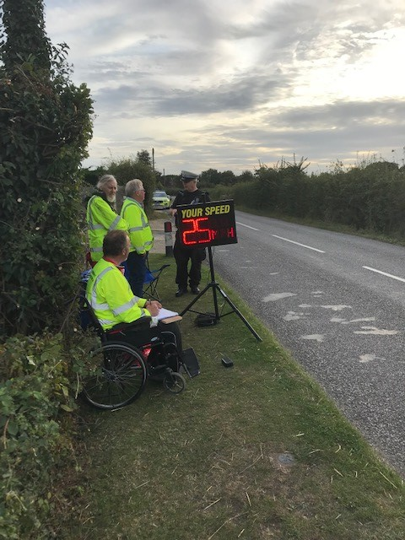We had time to say hello to the Shadoxhurst Speed Watch team who do a valuable job in our communities making there roads safer. With the assistance of one of our Traffic officers a few cars were stopped and words of advice were given to those drivers about their speed. Speed Watch teams are valuable to our different communities, and their dedication is amazing. We have active groups in Tenterden, St. Michaels, Shadoxhurst, Smallhythe to name just a few, and more Parishes are looking at setting up their own or re- activating their groups. If there are any Parishes that do not have a Speed Watch set up and would like more information please contact the community speed watch team to volunteer, to start a scheme, for support or assistance, or to arrange safety awareness training or have a risk assessment carried out at a new site. To set up a group ideally you need between 3-4 willing volunteers. We also have 2 Speed Watch units at Ashford Station which we can lend out to Parishes to use if they do not have their own equipment.

 Any further information please

**Call:** **01622 653781**

Email: [speedwatch@kent.police.uk](mailto:speedwatch@kent.police.uk)

You can also follow the team on Twitter @kentspeedwatch so I would please ask that we support them.

Sadly we are still having reports of Anti- Social Behaviour in some of our Parishes. Myself and Carin have been working closely with those committees to try and put a stop to this. We work with our colleagues the community wardens as well. Please can I ask parents to be aware of what your youngsters are up to in the community especially if they are out late at night. It isn’t all of them, and we don’t want to stop them being out and about. Sadly it’s just a handful of mindless youngsters that are spoiling it for others. We appreciate all the reports we get and if something is happening in your area please can I ask that you report it by the correct channels either through 101 or via the Kent Police website. If it’s not reported we are unaware it is happening.

Neighbourhood Watch schemes are working well in some of your areas. We have a lot of new homes being built so if anyone would like more information, myself and Neighbourhood Watch Andrew Judd will be in **Costa Coffee on Wednesday 23rd October from 10.00-12.00** please pop in and see us.

It’s that time of year where the nights are drawing in, please could you take a moment to read through the below steps on securing your property.

**At Home**.

* Lock all windows and doors before you go out or go to bed, making sure you know where your keys are in case of an emergency.
* Fit security measures such as intruder alarms, door chains and locks.
* Avoid labelling house keys in case you lose them and they fall into the wrong hands.
* Don’t leave keys (including car keys) or valuables on display near doors or windows.
* Make sure fences, hedges and gates are in good condition.
* Consider installing external security lights, but make sure they do not affect your neighbours.
* Avoid leaving side gates open and put away ladders, tools or garden equipment that could be stolen or used to break into your home.
* Keep garages and sheds locked and alarmed where possible.
* Store bins carefully so they cannot be used as climbing aids.
* Never hide spare house keys outside or in a shed.
* Dispose of packing carefully – empty boxes left outside your home could advertise your valuables to thieves.

**If you go away**

* Use timer switches on lights and radios to give the impression that someone is home.
* Cancel regular deliveries, such as milk and newspapers.
* Make sure garden furniture is stored away and lock sheds and gates.
* Ask a relative or trusted neighbour to pop in and move any post from inside your door.
* Arrange for the curtains to be opened and closed while you are away.
* Offer your neighbours the use of your driveway.

**All incidents that have been reported to police can be found in full depth from crime statistics which are available by visiting** [**www.police.uk**](http://www.police.uk)**.**

**I would like to remind all residents to stay vigilant and report anything suspicious online or via the Kent Police non-emergency number 101 or if you do witness a crime in progress then please do call 999.**

**Please do not report directly to me as there are days when I am not on duty and this could delay any actions that need to be taken, leading to potential loss of evidence.**



**Kate Richards PCSO 46059656**

**Community Safety Unit|** **Ashford Police Station | East Division**