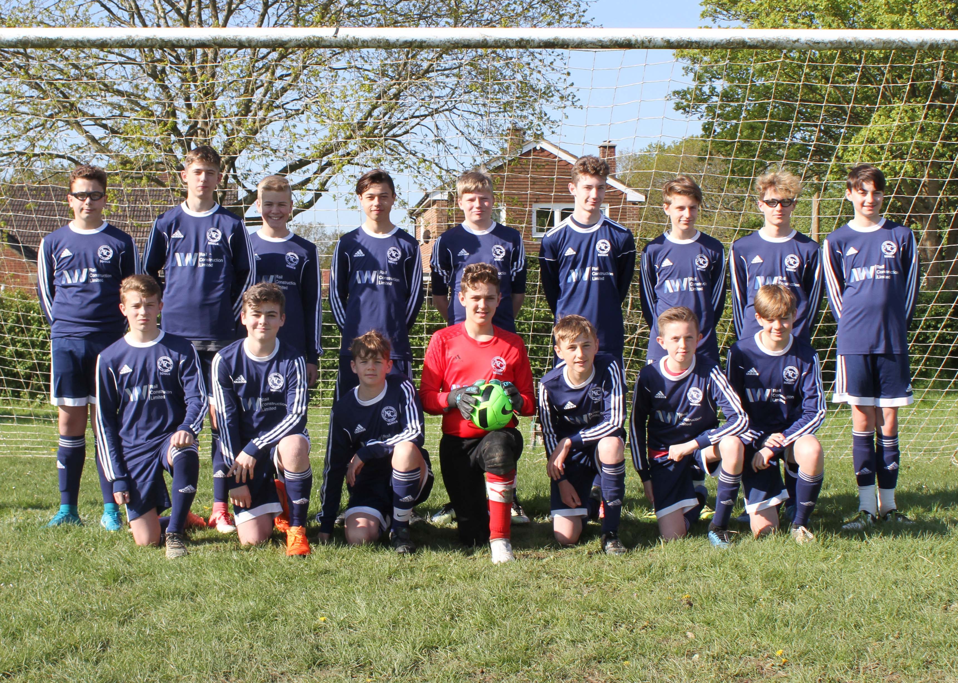  Ashford COURTSIDE SONICS U15’s  New players wanted for 2018/19 season.  We are looking for hardworking and committed players to join our U15 team for the coming season to play Sundays in the East Kent Youth League. We already have a fantastic group of players who are ready to take on a new challenge, if you love football and want to see what our club has to offer, then get in touch with club secretary Vanessa to find out more  -Tel- 07526431687  -Email- grimmond105@gmail.com | Ashford Courtside FC established in 2009.  ────  FA Charter Standard.  ────  Affiliated to Kent FA.  ────  All coaches are FA qualified.  ────  Home Ground- Shadoxhurst  Team Coach/ Manager  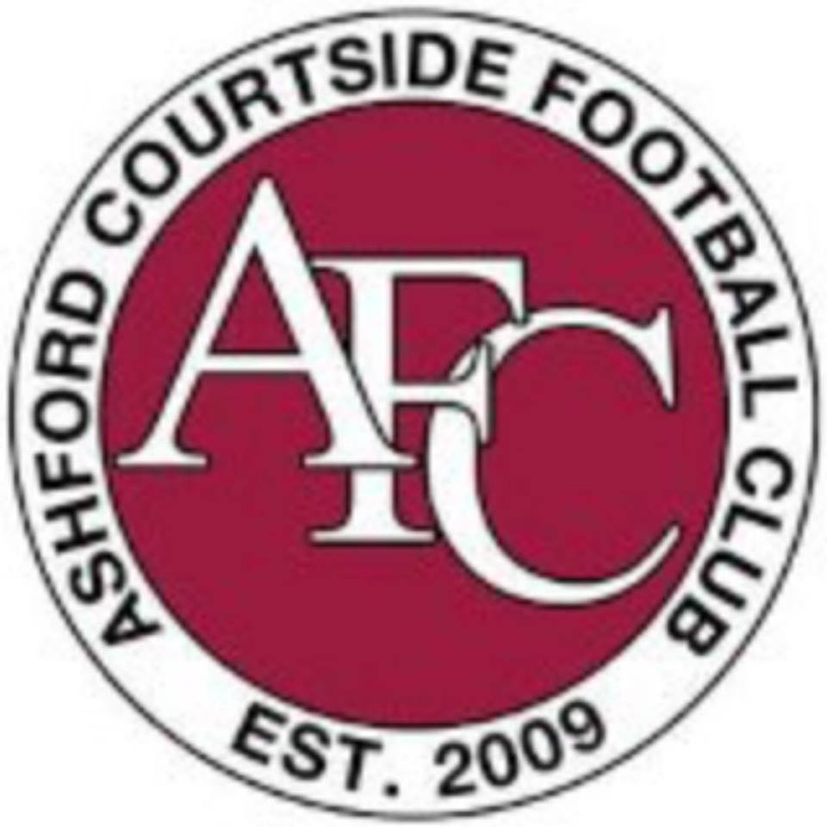  Emma Tune

